Crow Creek Tribal Schools
103 CHIEFTAIN ROAD - STEPHAN SD 57346
PHONE: 605-852-2455 1.800.370.7908
FAX: Elementary School 605-852-2181 Middle School 605.852.2573 High School 605-852-2401 WEBSITE: www.cctribalschools.org
2026-2027
NEW STUDENT ENROLLMENT APPLICATION
K-12/BETTER ALTERNATIVE


- APPLICATION MUST BE COMPLETE WITH ALL MANDATORY REQUIREMENTS FORMS NOTARIZE***

- **CCTS WILL NO LONGER ACCEPT FAXED APPLICATION, ORIGINAL MUST BE MAILED OR DELIVERED**

- INCOMPLETE APPLICATION PACKETS WILL NOT BE ACCEPTED
DORMITORY OPENS -August 13th (for FB/VB practice)
1ST DAY OF SCHOOL- August 18th
Football PRACTICE-August 13th
Volleyball Practice-August 13th

MISSION STATEMENT
“TO GUIDE OUR STUDENTS TO BECOME LIFELONG LEADERS IN EDUCATION, CULTURE AND THEIR EVERYDAY WALK IN LIFE”
Check List
√ Check off List | Student FORMS/Documents | COMPLETE | COMMENTS
Student Enrollment application-Educational Info, Social info Guardianship Documentation is Mandatory-
Temporary Custody form attached if needed
Birth Certificate-MANDATORY
Social Security Card [copy-optional]
Tribal Enrollment-MANDATORY
Immunization Record-MANDATORY
 | Transcript/Record Release
 | Check Out Form-MANDATORY NOTARIZED
 | Field Trip, Photo/Media Release, Religion/Sweat consent, Handbook Policy
 | BIE McKinley Vento form-Homeless/More than 1 family in home, overcrowded
 | BIE HOME Language Survey
Infinite Campus Student/Parent Portal
NASIS (Native American Student Information System) Secure website-student academic progress, attendance, schedule, Profile ect….
 | FERPA-Student/Parents rights for student records
 | Student Health forms- Over the Counter Medication, Health History, and Medical Power of Attorney. Mandatory Notarized
 | Counseling Forms Attached
 | Sun’wakan Wacinkiciya-Equine (horse) Wellness Program with student/families |  | 
 | Parent Compact Form

Dormitory Application will have IHS registration, consent forms and Physical-Sports SDHSAA-Pre-Participation Packet Forms you can also, pick them up at your local Indian Health Centers or find them on our website.
Falsification or withholding any information in this application will be grounds for non-acceptance or immediate dismissal of your child.
- Both natural parents of a child will be considered legal guardians of that child.
- The school must be notified of any special arrangements concerning the legal guardianship of your child or change of address and contact number.
- Any valid legal documents regarding guardianship must be provided for their student file.

CONTACT INFORMATION
Ph. 605-852-2455 Fax: 605-852-2401
Elementary School Middle School High School
Marcia Wells Marcella Howe Teresa Voice
Ext. 308 Ext. 354 Ext. 402

Crow Creek Tribal Schools
STUDENT ENROLLMENT APPLICATION

Parent/Guardian Information
Primary Parent/Guardian | Mailing Address | Physical Address | Contact #
Employed | Work Phone | Home Phone | Cell Phone
E-Mail Address | Emergency Contact | Emergency Contact # | Relationship to student
Mother Name: _______________________________ Father Name: ____________________________________
Address: ____________________________________ Address _________________________________________
City: _________________State: _______Zip: ______ City: _________________State: _______Zip: ___________
Contact #: _______________Email:______________ Contact #: _______________Email:___________________
Who does Students live with?
Mother/Stepfather Father/Stepmother Mother only Father Only  Both Parents  Foster Parents  Relative (Relationship to Student): ________________________ other: ______________________
PLEASE UPDATE ADDRESS---IF YOUR MAILING ADDRESS, PHONE NUMBER OR YOU MOVED (EVEN TEMPORARILY) YOU NEED TO NOTIFY THE SCHOOL and DORMITORY WITH THIS INFORMATION
(MANDATORY CUSTODY DOCUMENTS NEEDED):
ETHNICITY/RACE:
American Indian or Alaskan |  |  | Black or African American |  | Asian American
Hispanic/Latino |  |  | Native Hawaiian/Pacific Islander |  | White/Caucasian
Household Student Information K-12
First Name | MI | Last Name | Grade | DOB | Sex  M/F | SS# | Tribal Affiliation | Enrollment No.
1.
2.
3. |  | 
4.
5.
6.
7.
8.
9.
10.

Parent Signature __________________________________Date_________________

K-12 EDUCATIONAL INFORMATION
First Name | Last School  Attended | Reason for Leaving | Ever Suspended or Expelled | Reason Suspended or Expelled | Student in Sports (if so what sport)
1.
2.
3.
4.
5.
6.
7.
8.
9.
10.

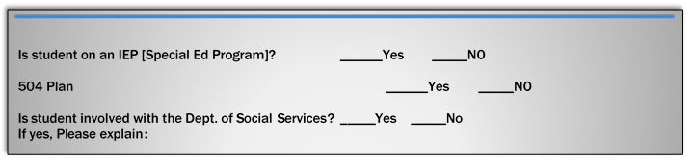
K-12 SOCIAL INFORMATION
First Name | Is student ward of court | Has student been arrested | Violations | Detention Center or Jail | Name & Contact of Probation Officer
1.
2.
3.
4.
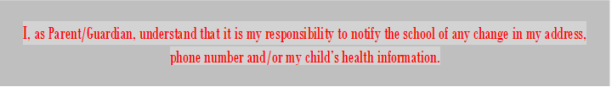

Crow Creek Tribal Schools/Transcripts/Records Release
103 Chieftain Road • Stephan, SD 57346
Telephone: 1-800-370-7908 Fax: 605-852-2573 Middle School
Middle School ext. 354 High School ext. 402 605.852.2401 High School
*Please complete and submit to the last school the student has attended.*

Student Last Name First MI

Address: ___________________________City:________________________State:_________Zip______

Home Phone: ___________________________ Cell or emergency #______________________________

I authorize the Principal, Counselor, Registrar and Special Education staff at:

Name of Previous School attended: ________________________________________________________

Address of Previous School: ___________________City:_______________State:________Zip__________

Dates Attended: ___________________________ to _________________________
Month/Year Month/Year
To release the following information: Crow Creek Tribal Schools

- Transfer Grades
- Last Report Card
- Transcripts
- Attendance
- Behavior Report
- Standard Test Results
- English Language Proficiency
- 504 Plan, Gifted and Talented Records
- Immunization, Covid 19 Vaccine-Mandatory
- Birth Certificate-MANDATORY
- Degree of Indian Blood-MANDATORY
- Social Security Card [copy] optional

•Special Education Records-please include: current or last IEP, Parental Consent, Team Summary, Evaluation Report, and Current Psychological Evaluation Report
- Other if any:____________________________________________________________________

_____________________________________________________ __________
Parent/Guardian Signature Date

_____________________________________________________ __________
School Official Date

FEDERAL LAW 99-31-*THERE IS NO PARENT SIGNATURE REQUIRED FOR EDUCATION RESOURCES TO BE SENT TO ANOTHER AGENCY.*
CROW CREEK TRIBAL SCHOOL
Check Out Form-NEW STUDENT ENROLLMENT
Policy: Only immediate family members can check-out dorm students. Immediate family is defined (as Mother, Father, Legal Guardian, Sister, brother, Grandparent, aunt or uncle.) This person must be at least 25 years of age [BIE guidelines]

It is very important the Parent/Legal Guardian have this form complete and notarized for the safety of our students. Students will not be allowed to check out of the dormitory or school unless they are released to a person whose name appears on this permission form. CCTS Staff are NOT allowed to check out dormitory students at any time, unless under special circumstances approved by the Principal, Dormitory Supervisor or Superintendent.

Student Name | Home Reservation

____________________________________________________________________________________
PO Box/Address City State Zip

- I hereby give the following adults permission to check out my son/daughter for week-ends or holidays.
- I understand that these adults must personally pick up the student and sign him/her out from the school (if during school hours) and from the dormitory.
- I understand that off reservation students may not check out to Ft. Thompson and surrounding communities for overnight unless with parents or legal guardian.
(Handwriting must correspond to notarized signature at bottom of the page for Dormitory AND New Student Application)
- I also give the school permission to seek out adequate housing and transportation for my son/daughter during emergencies.
[List names of adults for consent to check out student]

___________________________________ ____________________________________

___________________________________ ____________________________________

___________________________________ ____________________________________

___________________________________ ____________________________________

_______________________________________ __________________________________

Print Parent/Gurardian Name Emergency Contact Number

_____________________________________ _____________________________________
Signature of Parent/Legal Guardian Verified by Notary of the Public

___________________ _____________________________________
Date My Commission
BIE HOME Language Survey
School Year 2026-27

CCTS-School Mission Statement
“To Guide our Student to become long life leader in education, culture and their everyday walk in life”

Purpose: The responses to the home language survey will assist in determining if a student’s proficiency in English should be tested. This information is essential in order for the school to provide adequate instructional programs and service.

**As parent/guardians, your cooperation is requested in complying with these requirements.**

Student First Name: ________________________________Student Last Name: ________________________________________

Please respond to each of the questions listed as accurately and possible.

For each question, write the name(s) of the language(s) that apply in the space provided. Please do not leave and question unanswered.
If you have any questions you have the right to share them before your student’s English proficiency is assessed.

1. Which language did your child learn when they first began to talk?

2. Which language does your hold most frequently speak at home?

3. Which language do you (the parents/guardians) use more often when speaking with your child?

4. Which language is spoken more often by other adults in the home?

5. Do you believe your child might need additional support learning the academic language for math, science, reading, or writing?

Additional Information (Optional)

Please sign and date this form in the space provided below, then return this form to your child’s school.

Signature of Parent/Guardian __________________________________________________ Date: __________________

School official Verification____________________________________ Date: _______________ Thank you for your cooperation. Signature

Criteria for Screening -If language other than English is identified for any of the primary language questions above, your child will be recommended for screening. Thank you!

Federal Code: 25 CFR 32.3-Federal Requirements direct schools to assess the English Language proficiency of students. The process begins with determining the language(s) spoken in the home of each student. BIE has contracted with WIDA World (Class Instructional Design and Assessment) to provide English Learner Assessments and Supports identified in this Home Language Survey

CCTS Omakiya “Help” Program MCV Liaison Sammi Gourneau-Janis Ext. 270

BIE McKinney-Vento Act Housing Questionnaire

The McKinney-Vento Act ensures that all school-aged children and youth experiencing homelessness are entitled to the same free and appropriate public education that is provided to non-homeless students.
The questionnaire is intended to help determine eligibility for Omakiya services under the federal McKinney-Vento Act. The information provided is confidential and protected by the Family Education Rights and Privacy Act (FERPA). Information may be shared with the designated homeless liaison to determine eligibility and provision of services. You will be contacted if approved for Omakiya services you may appeal decision, if denied.

Student Name: ______________________________________________________ (M) or (F)
Address of where the students slept last night: _______________________________________
Guardian: ___________________________________________Relationship: _______________
Main Phone Number: ________________________________Email:_______________________
Is the student’s address a temporary living arrangement? Yes OR No
Please check all that apply to best describes students Primary Nighttime residence.
- Sharing Housing (Doubled up) with Family or Friends due to an economic hardship.
- In a hotel or motel
- Unsheltered (living in a car, park, campground, abandoned building).
- Shelter (living in a shelter, transitional housing); awaiting foster care placement
- In housing that does not have water, electricity or heat, mold or vermin infestations
- In my own home or apartment
- None of the above (describe my current living situation. Briefly describe your situation.
______________________________________________________________________________

______________________________________________________________________________
IF YOU LIVE IN YOUR OWN HOME OR APARTMENT, YOU MAY STOP HERE. THANK YOU.

List all children (infant/toddlers/school-aged children through age 21) that stay in the same location; even if they are not yet in school or have withdrawn from school:
First Name | Last Name | Age/Grade | School

_________________________________________________ ___________________
Signature of Parent/Guardian Date

CROW CREEK TRIBAL SCHOOL – Consent for Counseling
Confidentiality and Limits to Confidentiality
Trust and honesty are crucial to the development of all therapeutic relationships. Therefore, we place high value on the confidentiality of information you share within your sessions. You should, however, be aware that legal, ethical and licensure requirements specify certain conditions in which it may be necessary for your provider to discuss information about your care with other professionals.
Circumstances may occur:
- Danger that you may harm yourself or others, or are incapable for caring for yourself.
- Suspicion of abuse of children, elderly or disabled persons
- A Court Order to release your records.
- Your provider may sometime find it necessary to obtain professional consultation, in regards to the course of your care.
- Consultation regarding your case may be sought periodically with his/her supervisor and other colleagues only when needed.
- Your providers will inform you when he/she determines consultation is necessary. Your identity may or
may not be disclosed when this occurs.

I give permission for my child/children, __________________________________________________________________________________________________to receive counseling services through CROW CREEK TRIBAL SCHOOL. My signature below indicates that I understand that the counseling service is designed to help my child as he or she attends individual and/or group counseling sessions with the school Counseling Program

I understand that, as the parent/guardian of a minor, I legally have access to all information regarding my child’s treatment at Crow Creek Tribal School. However, I also understand that some measure of trust and confidentiality is necessary in order for my child’s treatment to be as effective as possible. Crow Creek Tribal School has my full consent to counsel my child/adolescent, and I understand that the counselor will notify me of any significant information and will update me regularly regarding my child’s counseling services.
Choose 1

Crow Creek Tribal School internal counseling service

Capital Area Counseling Service (mentor program)

I.H.S. School Based Counseling Service (School based Telehealth service)

Comments:_________________________________________________________________________________________

__________________________________________________________________________________________________

_____________________________________________________ _________________
Student Signature Date

________________________________________________ _____ _________________
Parent/Guardian Signature Date

STUDENT/PARENT ACTIVITY PERMISSION CONSENT

First Name | Last Name | Grade

ACTIVITY CONSENT | YES | NO
FIELD TRIP: Consent to go on class/activity groups
PHOTO/MEDIA RELEASE: Consent to use and publish my child (ren) photo, video, and media that may be displayed on CCTS Web Page and social media
RELIGION/SWEAT LODGE: Consent for my child to participate in sweat lodge ceremonies and/or attend the church of their choice for purification, prayer or personal spiritual guidance while attend CCTS.
Religion Affiliation:
PARENT/STUDENT HANDBOOK:
I verify I have read the PARENT/STUDENT HANDBOOK:

I hereby give my child (ren) permission to participate or not to participate as specified in activity as stated.

_________________________________________________ ___________________
Signature of Parent/Guardian Date


Crow Creek Tribal Schools-Infinite Campus Portal

Acceptable Use Policy
Crow Creek Tribal Schools under BIE has partnership with Infinite Campus web base program to track student educational information. Infinite Campus Portal as a means to further promote educational excellence and to enhance communication with parents and students. The Infinite Campus Portal allows parents and students (Grades K-12) to view school records anywhere at any time. In response for the privilege of accessing the Crow Creek Tribal Schools Infinite Campus Portal, every parent and student is expected to act in a responsible, ethical and legal manner. The Infinite Campus Portal is available to every parent/guardian who has a student enrolled at Crow Creek Tribal Schools. Parents and students are required to adhere to the following guidelines:
1. Parents and students will not share their passwords with anyone, including their children or
classmates.
2. Parents and students will not attempt to harm or destroy data of their own children, of
another user, school or district network, or the Internet.
3. Parents and student will not use the Infinite Campus Portal for any illegal activity, including
violation of Data Privacy laws. Anyone found to be violating laws will be subject to Civil
and/or Criminal Prosecution.
4. Parents and students will not access data or any account owned by another parent or student
5. Parents and students who identify a security problem with the Infinite Campus Portal must notify
the NASIS Coordinator immediately (852-2258 EXT. 354) or (Marcella. Howe@k12.sd.us)
without demonstrating the problem to anyone else.
6. Parents and students who are identified as a security risk to the Infinite Campus Portal will be
denied access to the Infinite Campus Portal.
User guidelines and system requirements can be found at www.cctribalschools.org. Please review them before signing and returning this document. You are required to sign and return this agreement before you receive access to the Infinite Campus Portal. Students must both sign and have a parent signature to gain access to the Infinite Campus Portal.
Please fill in all blanks (Print)
Parent(s) Name: _______________________________________Email Address: _________________________________

Children Information

Name: __________________________________________________ Grade: _________________
Name: __________________________________________________ Grade: _________________
Name: __________________________________________________ Grade: _________________
I have read the Infinite Campus Portal Acceptable Use Policy and I agree to abide by and support these rules.
I understand that if I violate any terms of this Acceptable Use Policy that I may lose my privilege to Infinite Campus Portal, and may be liable for civil and/or criminal consequences.

Student Signature _________________________________________________ Date: _____________

Parent Signature: __________________________________________________ Date: _____________

Temporary Custody/Guardianship Agreement

USE ONLY IF NOT LIVING WITH PARENT(S)

I, ____________________________, the biological legal parent of the following child (ren):

(Please list full names and date of birth)

I Do hereby give temporary custody to: (name and relationship to the child (ren):

Name Relationship to child (ren)

I currently reside at: _________________________________________________________________ and
Physical Address City State Zip
____________________________________________________currently resides at _______________
(My child (ren) name here) Physical Address
___________________________________________________________________________________.
City State Zip

I further give my permission for
_____________________________________________________ to care for my child (ren) in his/her home
(Signature of Temp guardianship here) and to apply for, consent to, or otherwise obtain any medical treatment or any economic, social, educational, check out or other services that my child(ren) my need. This Temporary Custody/Guardianship will expire on ________________________________________.

__________________________________________________
Print biological Parent

__________________________________________________ __________________________
Signature of biological Parent Date

__________________________________________________
(Print Name of Temp guardianship)

__________________________________________________ ____________________________
Signature of Temporary Guardianship Date

Taken, subscribed and sworn to before the undersigned authority this ________________day of ___________, 2______.

My commission expires _________________________________.

________________________________ _____________________________________________
Print Name-Notary Public Signature –Notary Public
Family Education Rights and Privacy Act (FERPA)

The Family Education Rights and Privacy Act of 1974, commonly known as FERPA, is a federal law that protects the privacy of student education records. Students have specific, protection rights regarding the release of such records and FERPA requires that institutions adhere strictly to these guidelines.

The following are statements that reflect what the Family Education Rights and Privacy Act (FERPA) covers concerning your rights as a parent and student:

- Parents are allowed to review all files and material the school has about their child.
- All schools are required to follow FERPA.
- The schools cannot provide a student with his/her parent’s financial records.
- A student can request that doctor of his/her choice review psychiatric or treatment records.
- FERPA does not allow the students to see the same files and records that their parent can see.
- A probation officer cannot see a student’s educational records without parental consent.
- The school is required to keep a list of all people who access a student’s records.
- Parents are allowed to bring someone with them to review their child’s school records.
- Parents are allowed to review their child’s testing protocols.
- Student Special Education records are the school’s responsibility to safeguard and no file should ever be left out of place where they can be seen by unauthorized people.
- Staff members can be reprimanded for failure to safeguard student records.

If you have further questions on your rights under the FERPA law then please feel to contact the school Principal or visit the www (World Wide Web) and do a search on FERPA. This will pull up the law, its interpretation and how it affects you as a parent/student.

By signing this form I have read all the above information.

__________________________________________________ ________________
Parent/Guardian Date

Know your rights!


Crow Creek Tribal Schools

A School-Parent Compact is a shared agreement that describes how parents, children, and the school will work together to support the child’s learning.
School-Parent Compact Form
103 Chieftain Rd Stephan SD 57346

Directions: Please read carefully this agreement that pertains to your responsibility, sign at the bottom to pledge this commitment to the education of our Students.

[Any person with a vested interest in helping this student may sign the compact in-lieu of the parent.]

Parent/Guardian: “I have entrusted in my child to the school to help prepare them for life. In order for my child to receive a quality education and to reach their fullest potential, I agree to”:
- Complete necessary forms to ensure my child (s) is officially registered for school.
- See that my child attends school on a daily basis and is in attendance for the day.
- Support the school in its effort to maintain proper discipline.
- Establish a time and place for doing homework and review homework regularly.
- Maintain an open line communication with my child and his/her teacher.
- Read with my child at least 15 minutes per day and let by child see me read.
- Be wear of my child’s interest and encourage either efforts.
- Visit Crow Creek Tribal School website www.cctribalschools.org on a regular basis.
- Attend parent survey on an annual basis to ensure the needs of my child are met.
___________________________ _________________________ __________________
Parent/Guardian Print Name Parent/Guardian Signature Date

Student: “Since I am investing in my future, it is important that I work to the best of my ability. Therefore, I will do the following”:
- Attend school on a daily and arrive on time.
- Come to school each day with all educational tools needed for learning.
- Complete daily work and return homework assignment in a timely manner.
- Do my best to prepare myself for test.
- Behave in a manner that contributes to the positive school environment.
- Respect classmates, school staff and myself.
___________________________ _________________________________ ______________________
Student Print Name Student Signature Date

Teacher: “Who I am and my student see me is as important as what I say, therefore, to help students achieve, I will try to do the following”:
- Demonstrate professional behavior and positive attitude.
- Maintain open lines of communication with students and their parents.
- Encourage Students and parents by providing information about student’s educational progress on a
Regular basis.
- Provide homework assignment as necessary to reinforce learning and teach responsibility.
- Treat each child in fair and equitable manner.
- Help each child reach his /her maximum learning potential
- Discuss the “No child Left Behind Law”, and how it affects my classroom to the parent of my students.
- Provide any parent(s) with any annual survey to express their needs as well as their child needs.
___________________________ _________________________________ ________________
Teacher Print Name Teacher Signature Date

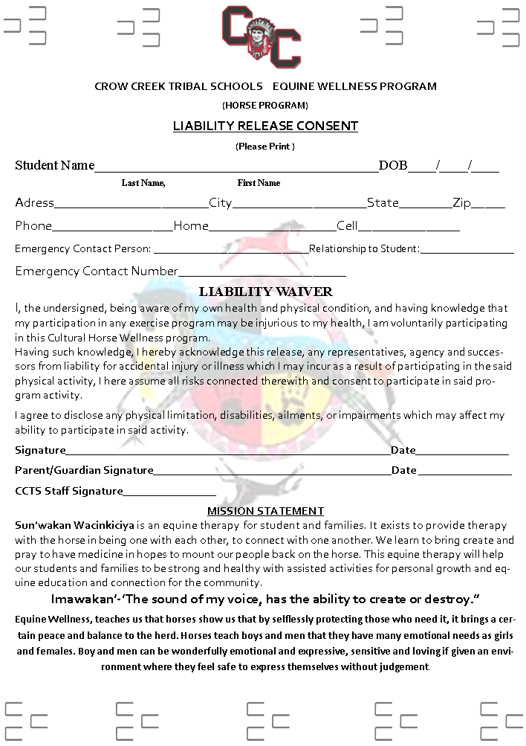

CROW CREEK TRIBAL SCHOOLS
School year 2026-27

103 CHIEFTAIN ROAD – STEPHAN, SOUTH DAKOTA 57346
NURSING DEPARTMENT
Medical Power of Attorney
(For the Care of a Minor Child)

I affirm that I am the parent and/or legal guardian of the minor child (ren) named below.

PRINT Parent / Guardian Full Name Today’s Date

CHILD’S NAME AGE/GRADE CHILD’S NAME AGE/GRADE

CHILD’S NAME AGE/GRADE CHILD’S NAME AGE/GRADE

CHILD’S NAME AGE/GRADE CHILD’S NAME AGE/GRADE

CHILD’S NAME AGE/GRADE CHILD’S NAME AGE/GRADE

CHILD’S NAME AGE/GRADE CHILD’S NAME AGE/GRADE

I, further, give consent to the CROW CREEK TRIBAL SCHOOL NURSING STAFF, DORMITORY/RESIDENTIAL STAFF AND CROW CREEK TRIBAL SCHOOL STAFF to provide the following health services for my child (ren):

- Health care including medical examinations, routine laboratory studies, x ray procedures, and skin tests
- Dental care including dental examination, preventative use of fluorides and necessary emergency dental care.
- Eye and Hearing Examinations
- Mental health services including evaluation and treatment as necessary
- Emergency health care for accidents or illness
- Transportation of the child (ren) to and/or from another health facility for these services.
I have read and UNDERSTAND this is a legal document and affirm my consent by signing my signature herein:

ADDRESS: _________________________________
ADDRESS CITY STATE/ZIP

RELATIONSHIP TO CHILD (REN): ______
Home Phone Cell Phone

______________________________________ _____________________________________
Signature of Parent/Legal Guardian Verified by Notary of the Public

_______________________ _____________________________________
DATE My Commission Expires

>>>>>>>>>THIS CONSENT EXPIRES AT THE END OF SCHOOL YEAR MAY 2027<<<<<<<<

CROW CREEK TRIBAL SCHOOLS
School year 2026-27 NURSING DEPARTMENT

103 CHIEFTAIN ROAD – STEPHAN, SOUTH DAKOTA 57346

STUDENT HEALTH HISTORY FORM-COMPLETED ANNUALLY

1. Student Name: Age: DOB: Gender: Grade:
Medical Diagnosis:_____________________________________________________________________________________________
Allergies:____________________________________________________________________________________________________
Medication:__________________________________________________________________________________________________

2. Student Name: Age: DOB: Gender: Grade:
Medical Diagnosis:_____________________________________________________________________________________________
Allergies:____________________________________________________________________________________________________
Medication:__________________________________________________________________________________________________

3. Student Name: Age: DOB: Gender: Grade:_________
Medical Diagnosis:_____________________________________________________________________________________________
Allergies:____________________________________________________________________________________________________
Medication:__________________________________________________________________________________________________

4. Student Name: Age: DOB: Gender: Grade:
Medical Diagnosis:_____________________________________________________________________________________________
Allergies:____________________________________________________________________________________________________
Medication:__________________________________________________________________________________________________

5. Student Name: Age: DOB: Gender: Grade:
Medical Diagnosis:_____________________________________________________________________________________________
Allergies:____________________________________________________________________________________________________
Medication:__________________________________________________________________________________________________

6. Student Name: Age: DOB: Gender: Grade:
Medical Diagnosis:_____________________________________________________________________________________________
Allergies:____________________________________________________________________________________________________
Medication:__________________________________________________________________________________________________
This form is a consent to allow school nurse(s) to administer OTC medications, including the following are over the counter medication:
Anti-biotic Cream (i.e. Bacitracin, Triple Anti-biotic Ointment) Hydrocortisone Cream (i.e. Anti-Itch Relief)
Oral Products (i.e. Oragel, Chloroseptic) Anti-septic Spray /topical (i.e. Bactine) Cold/Cough Medicine (Guaifenesin, Phenlephrine, Pseudoephedrine, Cough Drops) Antihistamine (i.e. Benadryl, Loratadine) NSAIDS (i.e. Motrin, Advil, Ibuprofen)
Antipyretic (i.e. Tylenol) Antacids (i.e. Mylanta, Maalox, Tums) Burn Relief Gel
Eye drops (i.e. Sodium Chloride)
PARENT / GUARDIAN SIGNATURE REQUIRED